DBMS Technical Task
Dhanalakshmi K
E25AI110
BSc. Computer Science
With
Artificial Intelligence

Week 4: Customer Order Management and Order History System

Aim of the Project
After a customer places an order, the system stores the overall order information and the details of the individual products included in that order.
The Orders table stores the main information about each order, including the customer who placed the order, order date, total amount, order status, and shipping information.
The Order_Details table stores the products included in each order along with their quantity and price. Since an order can contain multiple products and a product can be included in multiple orders, the Order_Details table is used to establish the relationship between Orders and Products.

Create Orders and Order_Details Tables
Orders Table
The Orders table stores the main information about orders placed by customers on the e-commerce platform.
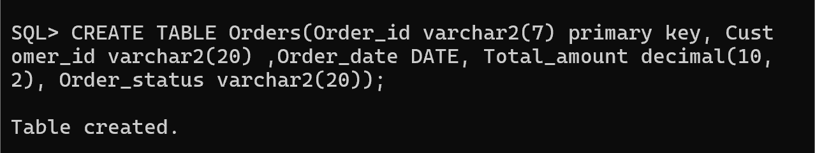

Order_Details Table
The Order_Details table stores information about individual products included in an order.
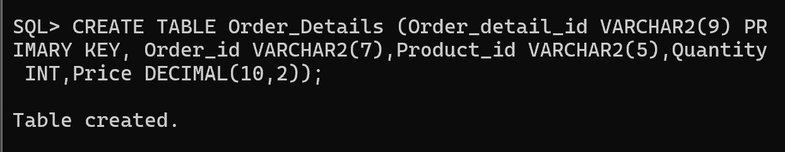

Establishing Relationships
After creating the Orders and Order Details tables, relationships were established between the tables using foreign keys. The Customer_ID in the Orders table refers to the corresponding Customer in the Customer table. Similarly,In Order Details Table Order_id connects the Orders table and Product_id connects the Product table Using foreign key .
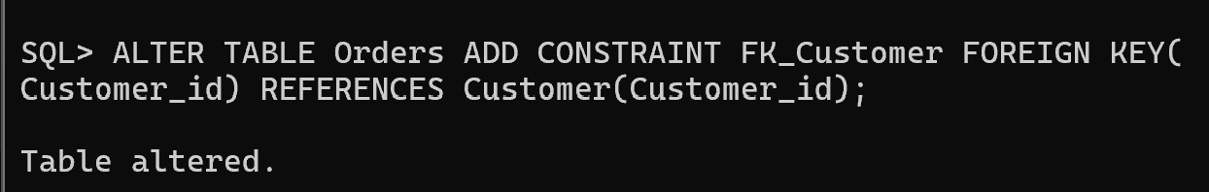

Applying Constraints for Data Integrity
Applied to make sure that the database accepts only valid and meaningful data.
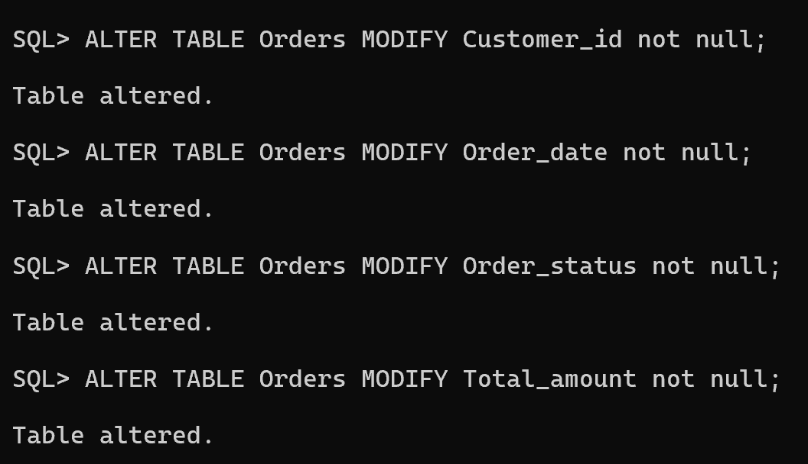
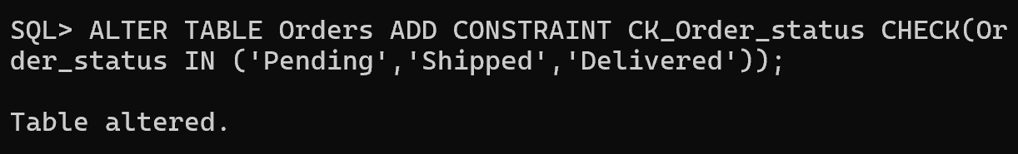
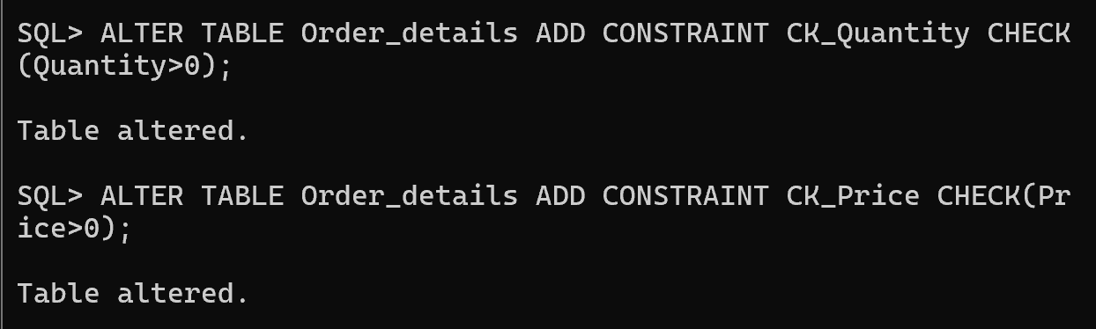

Inserting Values
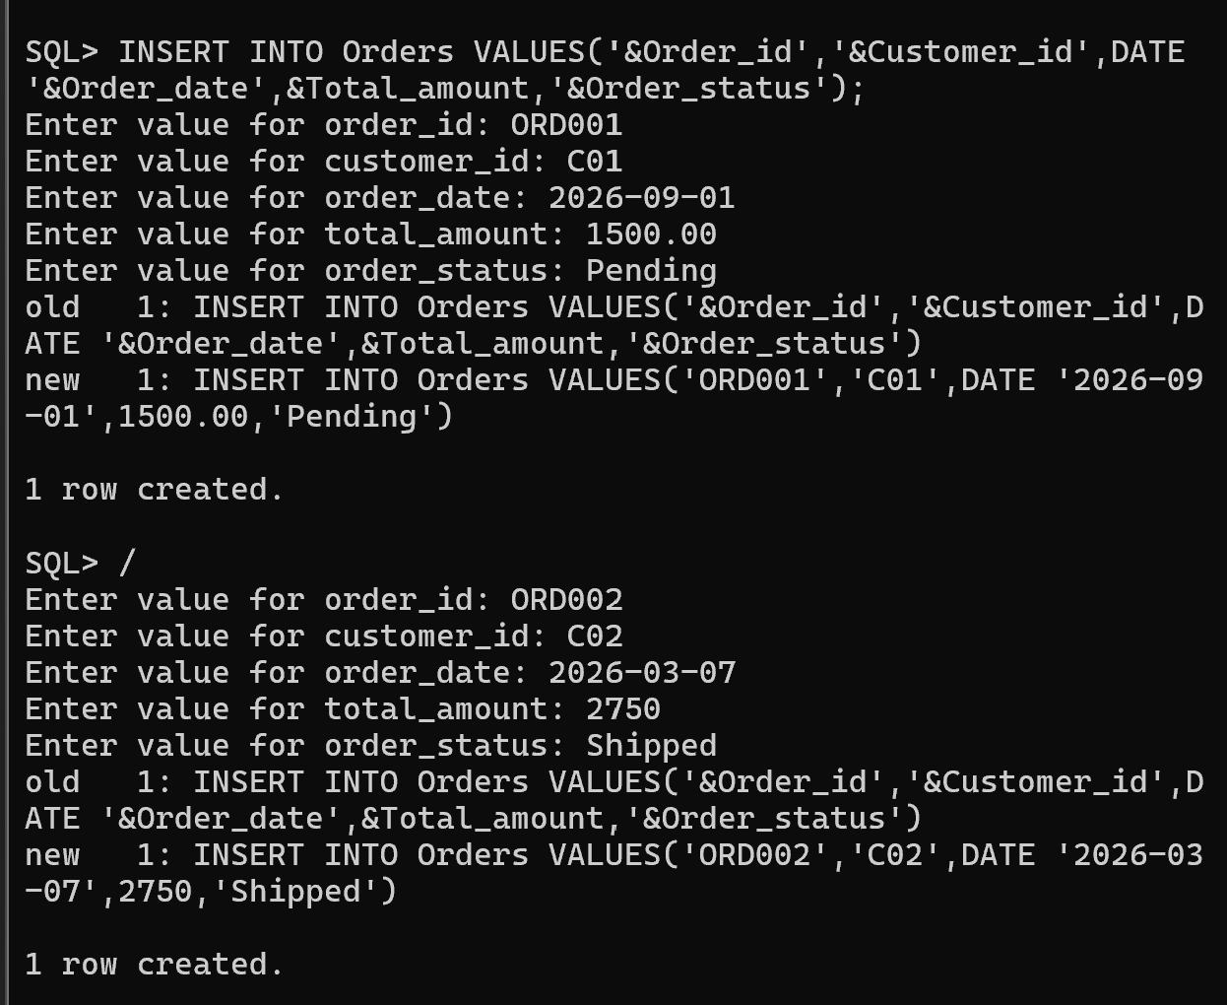
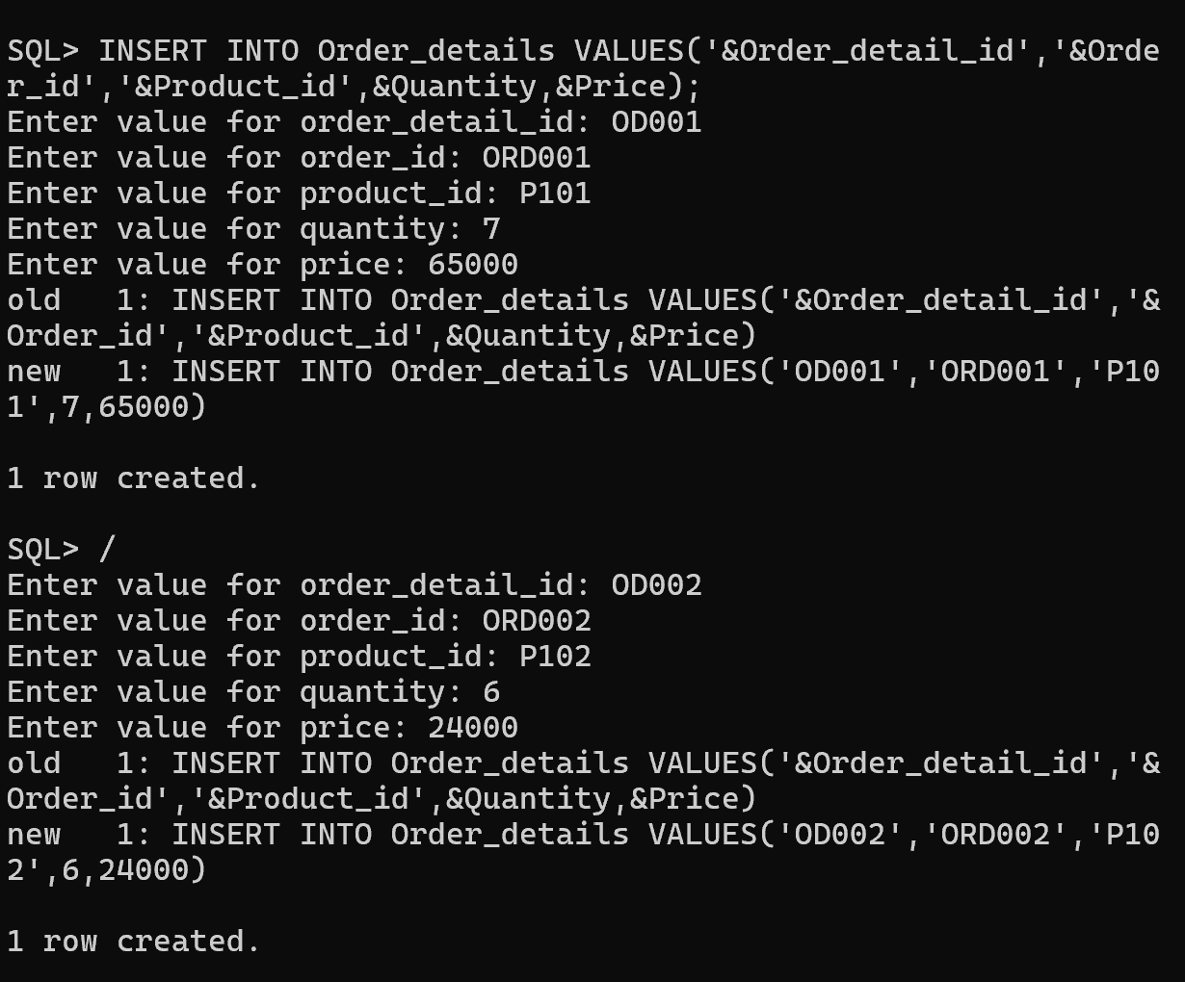

After Inserting Values:
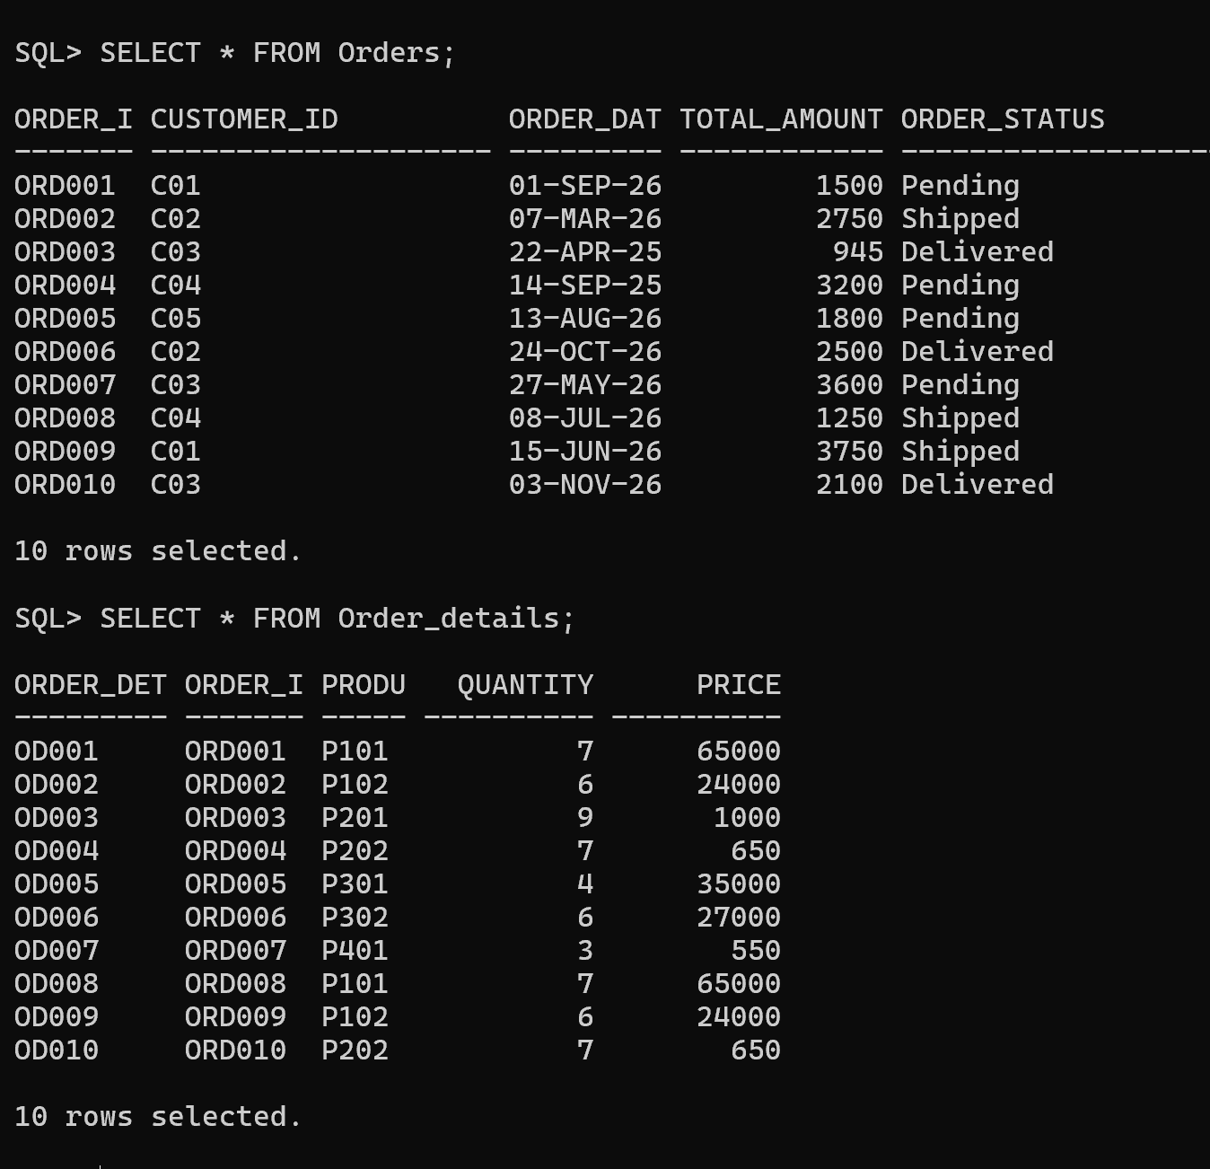

Report 1: Customer Order History
Displays:
• Customer Name
• Order ID
•Order Date
• Total Amount
• Order Status

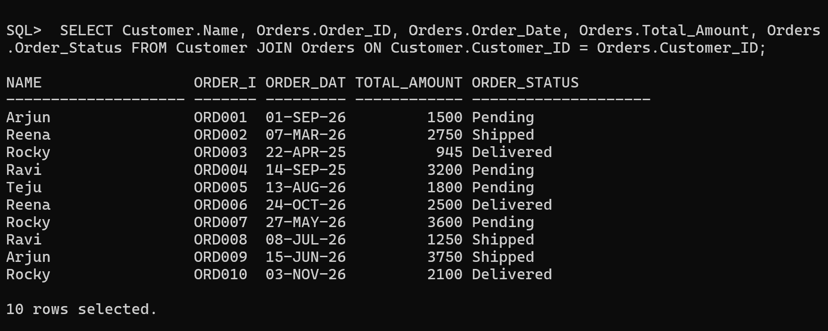

Report 2: Product-wise Order Report
Number of times each product was ordered. Total quantity of each product sold.
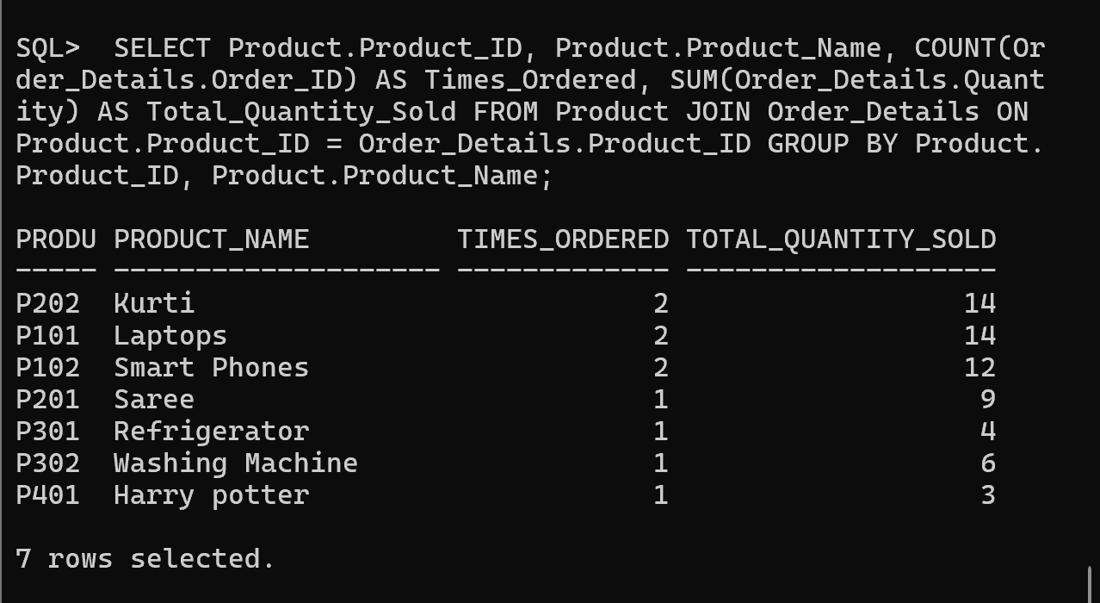

Report 3: Customer Purchase Analysis
Customers with Maximum Orders:
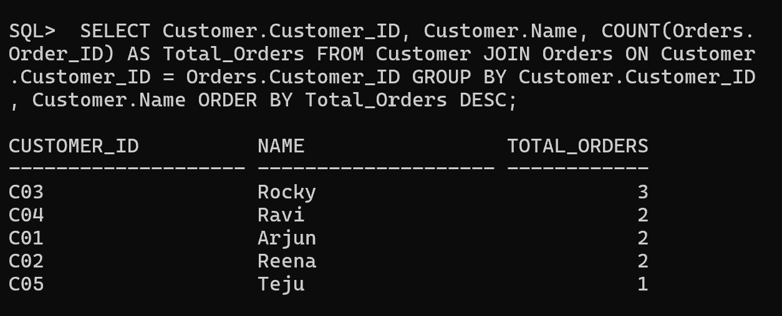
Total Spending by Each Customer:
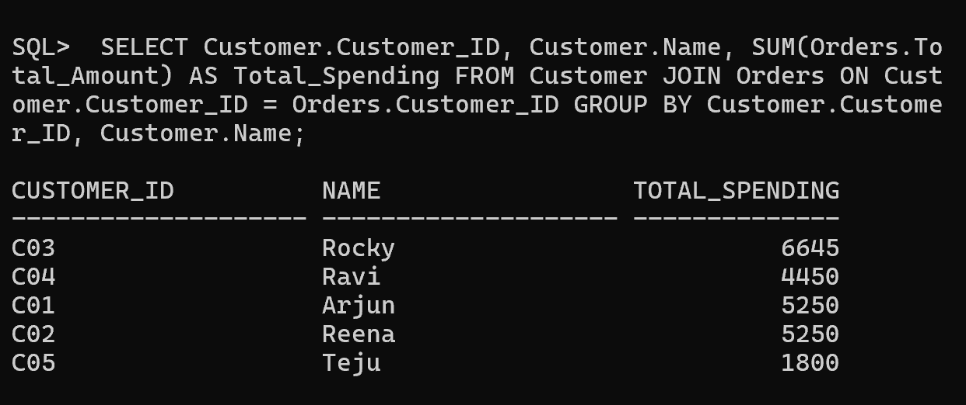
Average Order Value:
